# **What is the Internet?**

Formal definition:

"The Internet, a loosely-organized international collaboration of autonomous, interconnected networks, supports host-to-host communication through voluntary adherence to open protocols

and procedures defined by Internet Standards."

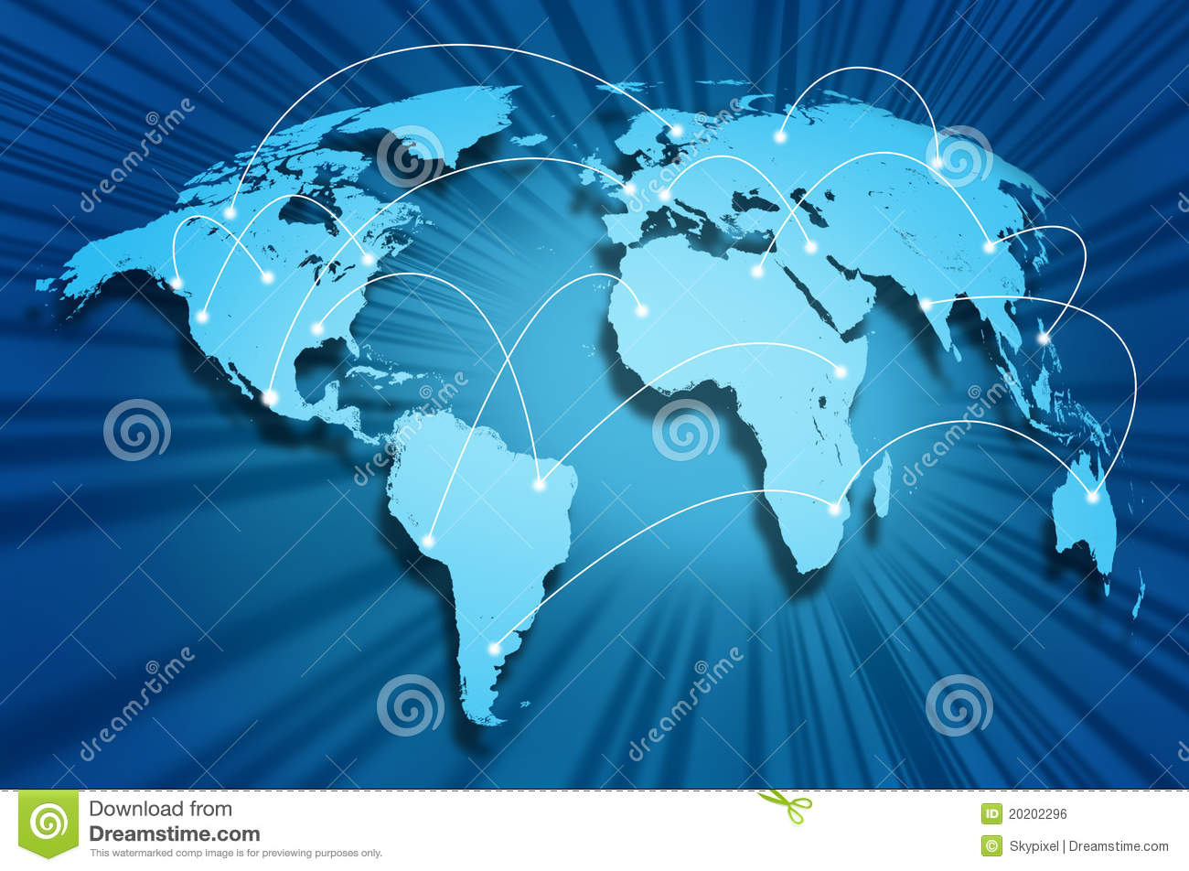

Another definition:

A collection of multiple different pieces of computer and non-

computer equipment talking to one another by means of a

communications network either wired or wireless.

<https://en.wikipedia.org/wiki/Internet>

<https://thumbs.dreamstime.com/z/internet-globe-20202296.jpg>

# **Domain names and ICANN**

Domain names:

Domain name is the address of your website that people type in the browser URL bar to visit your website.

When you enter a domain name in your web browser, it first sends a request to a global network of servers that form the Domain Name System (DNS). These servers then look up for the name servers associated with the domain and forward the request to those name servers. The server may have that address stored locally or may need to request that information from another server.

<https://www.wpbeginner.com/beginners-guide/beginners-guide-what-is-a-domain-name-and-how-do-domains-work>

<https://moz-static.s3.amazonaws.com/learn/seo/Domains-page/_large/domain-description-image.png?mtime=20170320080539>

ICANN:

To reach another person on the Internet you have to type an address into your computer - a name or a number. That address has to be unique so computers know where to find each other. ICANN coordinates these unique identifiers across the world. Without that coordination we wouldn't have one global Internet. 

ICANN was formed in 1998. It is a not-for-profit partnership of people from all over the world dedicated to keeping the Internet secure, stable and interoperable. It promotes competition and develops policy on the Internet’s unique identifiers.

ICANN doesn’t control content on the Internet. It cannot stop spam and it doesn’t deal with access to the Internet. But through its coordination role of the Internet’s naming system, it does have an important impact on the expansion and evolution of the Internet.

<https://www.icann.org/resources/pages/what-2012-02-25-en>

<https://www.icann.org/assets/icann_logo-060b2be98ed365541773152e2d7bb0ce5777c299d04fce4d89a14bc8fbc2a14a.png>

# **IP Addresses, Packets and Routing**

**IP address**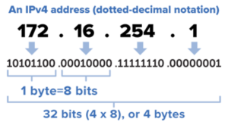

An IP address is a unique address that identifies a device on the internet or a local network. IP stands for "Internet Protocol," which is the set of rules governing the format of data sent via the internet or local network.

An IP address is a string of numbers separated by periods. IP addresses are expressed as a set of four numbers — an example address might be 192.158.1.38. Each number in the set can range from 0 to 255. So, the full IP addressing range goes from 0.0.0.0 to 255.255.255.255.

IP addresses are not random. They are mathematically produced and allocated by the Internet Assigned Numbers Authority (IANA), a division of the Internet Corporation for Assigned Names and Numbers (ICANN).

<https://www.kaspersky.com/resource-center/definitions/what-is-an-ip-address>

<https://netspeed.one/wp-content/uploads/2020/03/what-is-ip-address.png>

# **Packets**

A packet is the unit of data that is routed between an origin and a destination on the Internet or any other packet-switched network. Network packets are small (around 1.5 KBS for Ethernet packets and 64 KBS for IP packet payloads) amounts of data passed over TCP/IP networks. As an example, e-mails and web pages will make use of network packets to send information back and forth to the user and recipients. The goal of a network packet is to send information reliably so data does not have to be sent as a single, large file. 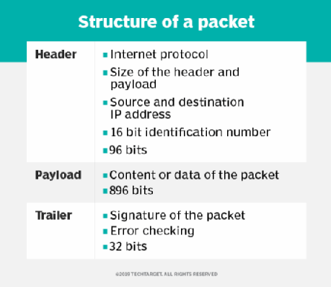

<https://searchnetworking.techtarget.com/definition/packet>

# [**https://cdn.ttgtmedia.com/rms/onlineimages/whatis-packet_structure_half_column_desktop.png**](https://cdn.ttgtmedia.com/rms/onlineimages/whatis-packet_structure_half_column_desktop.png)

# **Routing**

In networking, routing is the process of moving a packet of data from source to destination. The principles of routing can apply to many networks such as circuit-switched networks and computer networks. Routing is typically performed by a specialized device known as a router.

Routing is a core feature of the internet, where the router selects the paths for Internet Protocol (IP) packets to travel from their origin to the destination.

When a router receives a packet, it reads the headers of the packet to see its intended destination. It then determines where to route the packet based on information in its routing table. As a packet travels to its destination, it may be routed multiple times by several routers. Routers perform this process millions of times a second with millions of packets.

<https://www.webopedia.com/definitions/routing/>

<https://media.geeksforgeeks.org/wp-content/uploads/ccoco-1.png>

# **DNS**

The domain name system, or DNS, is a system designed to make the Internet accessible to human beings. The main way computers that make up the Internet find one another is through a series of numbers, with each number (called an “IP address”) correlating to a different device. However it is difficult for the human mind to remember long lists of numbers so the DNS uses letters rather than numbers, and then links a precise series of letters with a precise series of numbers.

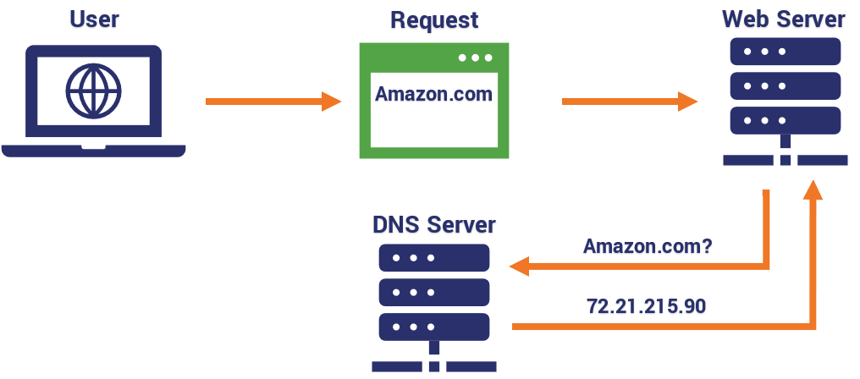

The end result is that ICANN’s website can be found at “icann.org” rather than “192.0.32.7” – which is how computers on the network know it. One advantage to this system – apart from making the network much easier to use for people – is that a particular domain name does not have to be tied to one particular computer because the link between a particular domain and a particular IP address can be changed quickly and easily. This change will then be recognised by the entire Internet within 48 hours thanks to the constantly updating DNS infrastructure. The result is an extremely flexible system.

<https://icannlac.org/EN/about-icann>

<https://www.icann.org/resources/pages/what-2012-02-25-en>

<https://cdn.business2community.com/wp-content/uploads/2021/01/DNS-Diagram.png>

# **HTTP and HTTPS protocols**

HTTP is Hypertext Transfer Protocol. HTTP offers a set of rules and standards which govern how any information can be transmitted on the World Wide Web. HTTP provides standard rules for web browsers & servers to communicate.

HTTPS stands for HyperText Transfer Protocol Secure. It is a highly advanced and secure version of HTTP. It uses the port no. 443 for Data Communication. It allows secure transactions by encrypting the entire communication with SSL. It is a combination of SSL/TLS protocol and HTTP. It provides encrypted and secure identification of a network server.

HTTPS protocol is an extension of HTTP. That “S” in the abbreviation comes from the word Secure and it is powered by Transport Layer Security (TLS) [the successor to Secure Sockets Layer (SSL)], the standard security technology that establishes an encrypted connection between a web server and a browser.

Without HTTPS, any data you enter into the site (such as your username/password, credit card or bank details, any other form submission data, etc.) will be sent plaintext and therefore susceptible to interception or eavesdropping. For this reason, you should always check that a site is using HTTPS before you enter any information.

In addition to encrypting the data transmitted between the server and your browser, TLS also authenticates the server you are connecting to and protects that transmitted data from tampering.

<https://www.guru99.com/difference-http-vs-https.html>

<https://www.globalsign.com/en/blog/the-difference-between-http-and-https>

<https://www.guru99.com/images/1/053018_0552_HTTPvsHTTPS1.png>

# **W3C and HTML and CSS**

**W3C**

The World Wide Web Consortium is the main international standards organization for the World Wide Web. Founded in 1994 and currently led by Tim Berners-Lee, the consortium is made up of member organizations that maintain full-time staff working together in the development of standards for the World Wide Web.

The World Wide Web Consortium (W3C) is an international consortium where Member organizations, a full-time staff, and the public work together to develop Web standards and guidelines designed to ensure long-term growth for the Web. W3C's goal is for the Web to connect humanity in a way that makes access to knowledge more efficient and equitable.

**HTML**

HTML stands for Hyper Text Markup Language. It is the standard markup language for creating Web pages. HTML describes the structure of a Web page and it consists of a series of elements.

HTML elements tell the browser how to display the content. HTML elements label pieces of content such as "this is a heading", "this is a paragraph", "this is a link", etc. and example of HTML code is as follow;

|  |
| --- |
| <!doctype html>  <html lang=**"en"**>  <head>  <!-- Required meta tags -->  <meta charset=**"utf-8"**>  <meta name=**"viewport"** content=**"width=device-width, initial-scale=1"**>  <link href=**"css/myStyle.css"** rel=**"stylesheet"**>  <!-- Bootstrap CSS -->  <link href=**"https://cdn.jsdelivr.net/npm/bootstrap@5.0.0-beta2/dist/css/bootstrap.min.css"** rel=**"stylesheet"**  integrity=**"sha384-BmbxuPwQa2lc/FVzBcNJ7UAyJxM6wuqIj61tLrc4wSX0szH/Ev+nYRRuWlolflfl"** crossorigin=**"anonymous"**>  <title>**History of the Internet home page**</title>  </head>  <body>  <div class=**"card mb-3"**><!--Header banner-->  <img src=**"images/dsBuffer.jpg"** class=**"img-fluid"** alt=**"Internet"**>  <div class=**"card-body"**>  <h5 class=**"card-title"**>**History of the Internet**</h5>  <p class=**"card-text"**>**IS 601 - History of Internet Website**</p>  </div>  </div>  <ul class=**"nav nav-pills nav-justified"**>  <li class=**"nav-item"**>  <a class=**"nav-link"** href=**"index.html"**>**Home**</a>  </li>  <li class=**"nav-item"**>  <a class=**"nav-link "** href=**"about.html"**>**About**</a>  </li>  <li class=**"nav-item"**>  <a class=**"nav-link"** href=**"team.html"**>**Team**</a>  </li>  <li class=**"nav-item"**>  <a class=**"nav-link"** href=**"TheInventionOfTheInternet.html"**>**The Invention of the Internet**</a>  </li>  <li class=**"nav-item"**>  <a class=**"nav-link"** href=**"BrowserWars.html"**>**Browser Wars**</a>  </li>  <li class=**"nav-item"**>  <a class=**"nav-link"** href=**"InternetSearch.html"**>**Internet Search**</a>  </li>  <li class=**"nav-item"**>  <a class=**"nav-link"** href=**"DotComBubble.html"**>**Dot Com Bubble**</a>  </li>  <li class=**"nav-item"**>  <a class=**"nav-link"** href=**"People.html"**>**People**</a>  </li>  <li class=**"nav-item"**>  <a class=**"nav-link"** href=**"HistoryOfInternetWebsite.html"**>**History of Internet Website**</a>  </li>  </ul>  <div class=**"intro"**>  **This website is a part of the IS601 class.**  **It demonstrates the History of the internet based on some documentries.**  </div>  <!-- Optional JavaScript; choose one of the two! -->  <!-- Option 1: Bootstrap Bundle with Popper -->  <script src=**"https://cdn.jsdelivr.net/npm/bootstrap@5.0.0-beta2/dist/js/bootstrap.bundle.min.js"**  integrity=**"sha384-b5kHyXgcpbZJO/tY9Ul7kGkf1S0CWuKcCD38l8YkeH8z8QjE0GmW1gYU5S9FOnJ0"**  crossorigin=**"anonymous"**></script>  </body>  </html> |

**CSS**

CSS stands for Cascading Style Sheets. CSS describes how HTML elements are to be displayed on screen, paper, or in other media. CSS saves a lot of work. It can control the layout of multiple web pages all at once. External stylesheets are stored in CSS files. An example of CSS code;

|  |
| --- |
| **.**intro **{**  **background-color: whitesmoke;**  **border: lightgray;**  **border-style: solid;**  **border-width: medium;**  **margin: 2%;**  **padding: 2%;**  **}**  **.**timeline **{**  **position: relative;**  **padding: 21px 0px 10px;**  **margin-top: 4px;**  **margin-bottom: 30px;**  **}**  **.**timeline **.**line **{**  **position: absolute;**  **width: 4px;**  **display: block;**  **background: currentColor;**  **top: 0px;**  **bottom: 0px;**  **margin-left: 30px;**  **}**  **.**timeline **.**separator **{**  **border-top: 1px solid currentColor;**  **padding: 5px;**  **padding-left: 40px;**  **font-style: italic;**  **font-size: .9em;**  **margin-left: 30px;**  **}**  **.**timeline **.**line**::**before **{ top: -4px; }**  **.**timeline **.**line**::**after **{ bottom: -4px; }**  **.**timeline **.**line**::**before**,**  **.**timeline **.**line**::**after **{**  **content:** ''**;**  **position: absolute;**  **left: -4px;**  **width: 12px;**  **height: 12px;**  **display: block;**  **border-radius: 50%;**  **background: currentColor;**  **}**  **.**timeline **.**panel **{**  **position: relative;**  **margin: 10px 0px 21px 70px;**  **clear: both;**  **}**  **.**timeline **.**panel**::**before **{**  **position: absolute;**  **display: block;**  **top: 8px;**  **left: -24px;**  **content:** ''**;**  **width: 0px;**  **height: 0px;**  **border: inherit;**  **border-width: 12px;**  **border-top-color: transparent;**  **border-bottom-color: transparent;**  **border-left-color: transparent;**  **}**  **.**timeline **.**panel **.**panel-heading**.**icon **\* { font-size: 20px; vertical-align: middle; line-height: 40px; }**  **.**timeline **.**panel **.**panel-heading**.**icon **{**  **position: absolute;**  **left: -59px;**  **display: block;**  **width: 40px;**  **height: 40px;**  **padding: 0px;**  **border-radius: 50%;**  **text-align: center;**  **float: left;**  **}** |

<https://www.w3.org/>

<https://www.w3schools.com/html/>

<https://www.w3schools.com/css/>

<https://upload.wikimedia.org/wikipedia/commons/thumb/e/ed/W3C%C2%AE_Icon.svg/1200px-W3C%C2%AE_Icon.svg.png>